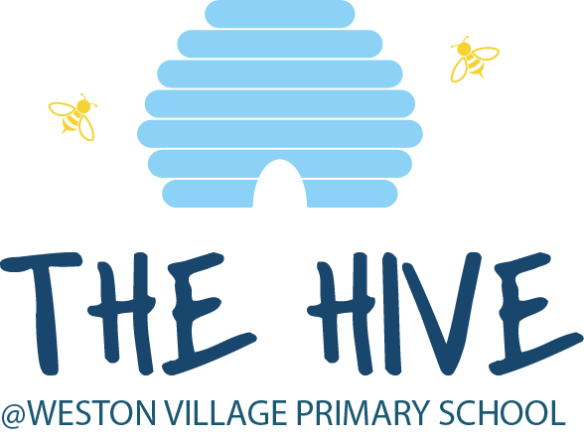

Out of School Club
Parents’ Handbook

East Avenue, Weston, Crewe, Cheshire, CW2 5LZ Tel: 01270 814848
Email: thehive@weston.cheshire.sch.uk
Web: www.weston.cheshire.sch.uk
Headteacher: Mr Thomas Cutts

The Cornovii Trust is a charity and a company limited by guarantee, registered in England and Wales with
company number 8597784 and having its registered office at Hassall Road, Alsager, Cheshire, ST7 2HR

ABOUT THE CLUB
The out of school club is registered with Ofsted (Registration No 145587), and is based at Weston Village Primary School. The club is open before school from 7.30am to 8.45am and after school from 3.15pm to 6.00pm weekdays, during term time. We also offer some holiday care from 7.30am to 6.00pm. We look forward to welcoming new families to come and try out the club.

We are predominately based in the main school hall, but do spend some afternoon sessions in the classrooms. We have use of all of the school’s outside play areas and the school’s sports equipment, and make every effort to include lots of outside play when weather allows.

Aims
At the Hive, we aim to provide a safe, secure and relaxed environment, whilst offering a range of activities to reflect the interests of the children in our care.

What we offer
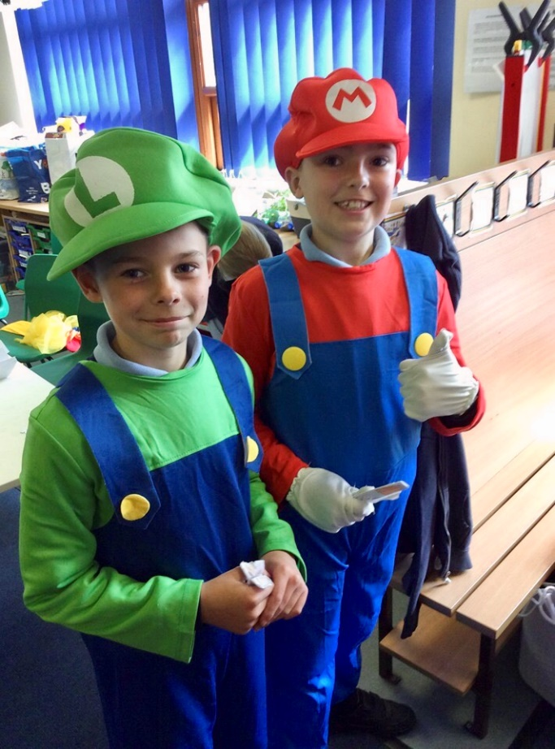
Our club follows the Playwork Principles, so the children are free to choose activities and resources as they wish. There will always be a selection of activities and resources available, including dressing up, craft, board games, construction, computer games, physical play, cookery, and reading. In addition, other resources are available for the children to select from our equipment library. Activities are subject to change as we always try to take advantage of good weather or the time kindly offered by the school teaching staff, whether in special sessions, homework club or existing teacher-led after school clubs.

What we provide
The evening snack is served between 4.00pm and 4.30pm, to enable the children to have a well-earned run around after the school day has finished. We provide various finger food snacks, including fresh fruit every day. A separate breakfast menu is served for morning sessions until 8.20am, offering cereals, toast, pancakes etc.

We promote independence by encouraging the children to clear away after themselves and help with the washing of dishes if they wish. We use fresh ingredients where possible and follow statutory guidelines. Fresh drinking water is available at all times. We meet individual dietary requirements and parental preferences wherever possible.
We recognise the importance of healthy nutrition for children delivered in a calm, friendly setting.

Staffing
Our club is staffed by a supervisor, two playworkers, and a finance officer. We also have a further number of casual support staff, who are also school employees.

All of our staff have significant experience of working with children and hold an enhanced DBS Certificate. We maintain a staff/child ratio of 1:8 for children under the age of eight.

If you have a query or concern at any time, please speak to a member of staff at the club when you collect your child. If you prefer to arrange a more convenient time for a meeting, please contact the supervisor. (Contact details are at the back of this handbook).

Organisation
The Hive is run as a not-for-profit business and any monies we do have are put back into the club and school, so that all our children benefit. We enjoy a close working relationship with Weston school in order to ensure continuity of care, and to maintain good communication links.

Policies and procedures
The club has clearly defined policies and procedures. Key points of the main policies are included in this handbook. Copies of the full policies are kept at the club and are available for parents to consult at all times.

TERMS AND CONDITIONS

Admission
Our club aims to be accessible to children and families from all sections of our local community. We require your child to be registered via the School Spider app, before they can attend the club. Information to help you get set up on School Spider can be found on our website. Parents are required to keep us informed of any changes to their contact details or circumstances.
Fees
Term Time:
Breakfast Session 7.30am – 8.45am: £5.50
After School Session 3.15pm – 6pm: £8.50

Holiday Club:
Full Day 7.30am – 6.00pm: £27.00

Payment of fees
All bookings and payments are managed through an online system - School Spider, which is accessible via a dedicated app. All sessions must be paid for in advance. Voucher payments are accepted and parents can upload a screenshot of the details into the app for approval.

The price per session per child applies to all children. This is payable for all booked sessions including when your child is sick (regardless of the amount of notice given). We do not charge for bank holidays.

Please ensure that fees are paid promptly. The booking window to add or cancel an afternoon session or the following morning breakfast session, closes at 2.15pm. This is to enable us to prepare the registers and ensure our staffing ratios are correct. If you are having difficulty paying fees, please speak in confidence to the Finance Officer.

Temporary changes
If your child doesn’t attend a session that remains ‘booked’, we will treat them as a ‘missing child’ unless you have notified us of their absence. Please contact The Hive directly rather than passing information on to a member of school staff.

Arrivals and departures
Our staff collect the children from their classrooms at the end of the school day and a register is taken.

If you need a different person to collect your child on a particular day, you must notify us in advance. We will not release your child into the care of a person unknown to us without your authorisation.

The club closes at 6.00pm. If you are delayed for any reason, please telephone the club to let us know. Should a child be subject to regular instances of late collection, we reserve the right to withdraw access to use the Hive service.

If your child remains uncollected after 6.30pm and you have not warned us that you will be delayed, and we have been unable to reach you or any of your emergency contacts, we will follow our Uncollected Children Policy and contact the Social Care team.

Child protection
We are committed to building a culture of safety in which the children in our care are protected from abuse and harm. Any suspicion of abuse is promptly and appropriately responded to. We comply with local and national child protection procedures and ensure that all staff are appropriately trained.

Equal opportunities
Our Club provides a safe and caring environment, free from discrimination, for everyone in our community including children with additional needs.

We respect the different racial origins, religions, cultures and languages in a multi-ethnic society so that each child is valued as an individual without racial or gender stereotyping. We will challenge inappropriate attitudes and practices. We will not tolerate any form of racial harassment.

Special educational needs and disabilities
We make every effort to accommodate and welcome any child with special educational needs. We will work in liaison with parents or carers and relevant professionals to fully understand your child’s specific requirements. We will endeavour to accommodate all children, whilst working within the club’s limitations. Each case will be considered individually and risk-assessed to ensure everyone’s safety. Our staff training programme includes specific elements relating to children with special educational needs and disabilities.
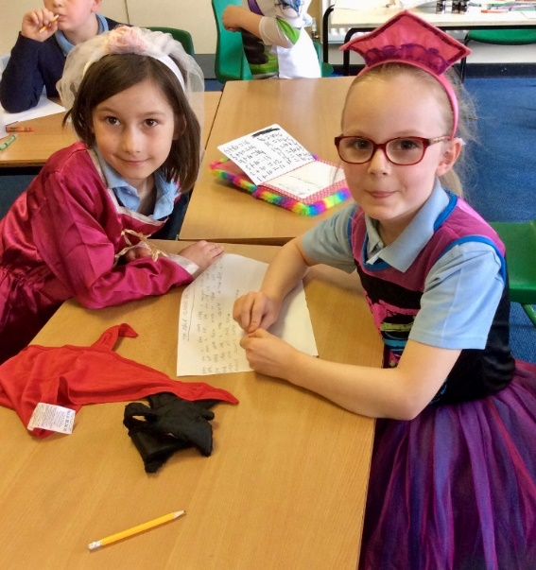
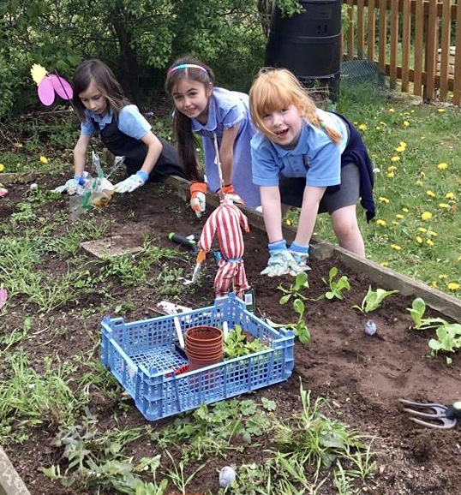

GENERAL INFORMATION

Behaviour (children)
Children and staff have created rules for acceptable behaviour whilst at the club. These are displayed on the club’s notice board located in the main hall for everyone to see.

The Club promotes an atmosphere of care, consideration and respect for everyone attending: children, staff and visitors.

We encourage appropriate behaviour through praise for good behaviour; emphasis on co-operative play and sharing; talking to children with the courtesy that we expect from them and engaging children in activities.

The Club has procedures for dealing with unacceptable behaviour. We recognise that poor behaviour can occur from time to time for reasons that are not always evident, or as a result of special educational needs. We will try to be flexible in order to accommodate such cases.

However, if your child is violent, or if their behaviour poses an immediate danger to themselves or others, we will require you to collect them from the club immediately. In exceptional circumstances, and only when all other attempts at behaviour management have failed, we reserve the right to permanently exclude a child from the club.

Behaviour (adults)
We will not tolerate from any person, whether a parent, carer or visitor, bullying; aggressive, confrontational or threatening behaviour; or behaviour intended to result in conflict. Our club is a place of safety and security for the children who attend and the staff who work here, and we reserve the right to ban anyone exhibiting inappropriate behaviour from our premises.

Illness
We are unable to care for children who are unwell. If your child becomes unwell whilst at the club, we will contact you and ask you to make arrangements for them to be collected. Please inform the supervisor of any infectious illness your child contracts. If your child has had sickness or diarrhoea, please do not send him or her to the club for 48 hours after the last bout of illness.

Accidents and first aid
Every precaution is taken to ensure the safety of the children at all times, and the club is fully insured. Our staff are trained in first aid and a first aid kit is kept on the premises. If your child has an accident whilst in our care, you will be informed when you collect your child.

Medication
Please let the supervisor know if your child is taking prescribed medicine. If your child needs to take medicine whilst at the club you will need to complete a ‘Permission to Administer Medication’ form in advance.

Complaint’s procedure
If you have any queries, comments or need to discuss any matters concerning your child, please feel free to speak to the Supervisor, or any other member of staff. Verbal complaints will be brought to the next staff meeting for discussion and action. All written complaints will be acknowledged within five working days of receipt and a full written response will be given within 28 days.

CONTACT INFORMATION

Weston Village Primary School,
East Avenue,
Weston,
Crewe,
CW2 5LZ

Email: thehive@weston.cheshire.sch.uk

School phone number: 01270 814848 (School hours only)

The Hive Class Dojo

Ofsted Registration No: 145587

Early Years and Childcare Service
Tel: 01625374700

Ofsted
Piccadilly Gate
Store Street
Manchester M1 2WD
Tel: 0300 123 1231

What the children say…

I like playing on the field and the kind staff
I like it when we do forest school

Year 2 pupil
Year 5 pupil
It’s very fun!
I like how there are activities for us all to play with
The best things are the food, the games and toys

Year 3 pupil

Year 4 pupil Year 5 pupil

What the parents say…

I really value the flexibility in being able to add sessions as my work commitments change. The children are well cared for and asked to move to this club from another provider. We've used the club for the last two years.
Year 2 parent

I’m pleased it’s a not-for-profit structure, so I know the fees go straight back to enhancing the club. And the kids love the extra time to play with their friends.
Year 5 parent

